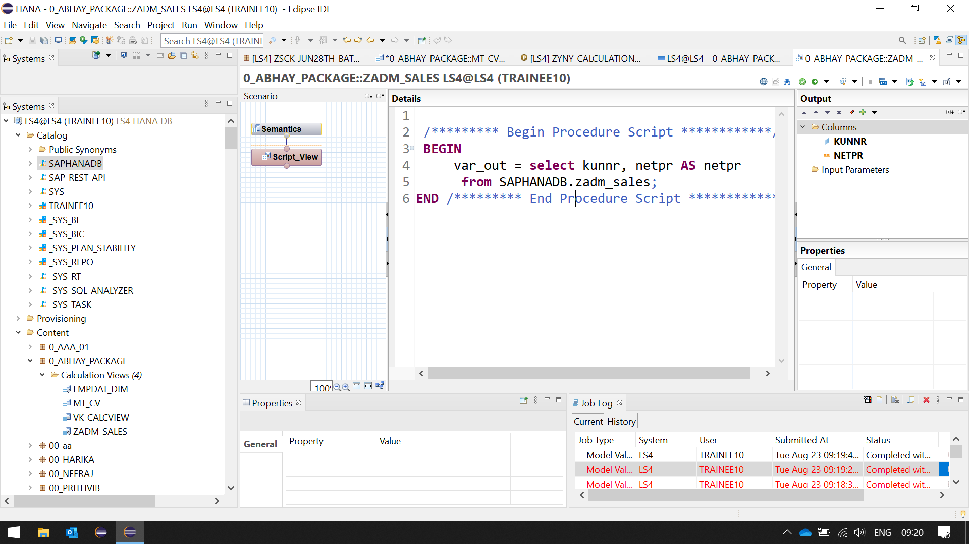

/********* Begin Procedure Script ************/

**BEGIN**

var_out = **select** kunnr, netpr **AS** netpr

**from** SAPHANADB.zadm_sales;

**END** /********* End Procedure Script ************/

var_out = select kunnr , netpr as netpr

from SAPLS4.zadm_sales;

____________________________________________________

Generated SQL is

1. SELECT

"KUNNR",

sum("NETPR") AS "NETPR"

FROM "_SYS_BIC"."pkg-trainee01.Z104329/CALC_VIEW_SCRIPT3"

GROUP BY "KUNNR"

**SELECT**

"KUNNR",

**sum**("NETPR") **AS** "NETPR"

**FROM** "_SYS_BIC"."0_ABHAY_PACKAGE/ZADM_SALES"

**GROUP** **BY** "KUNNR"

Execute this.

View the output.

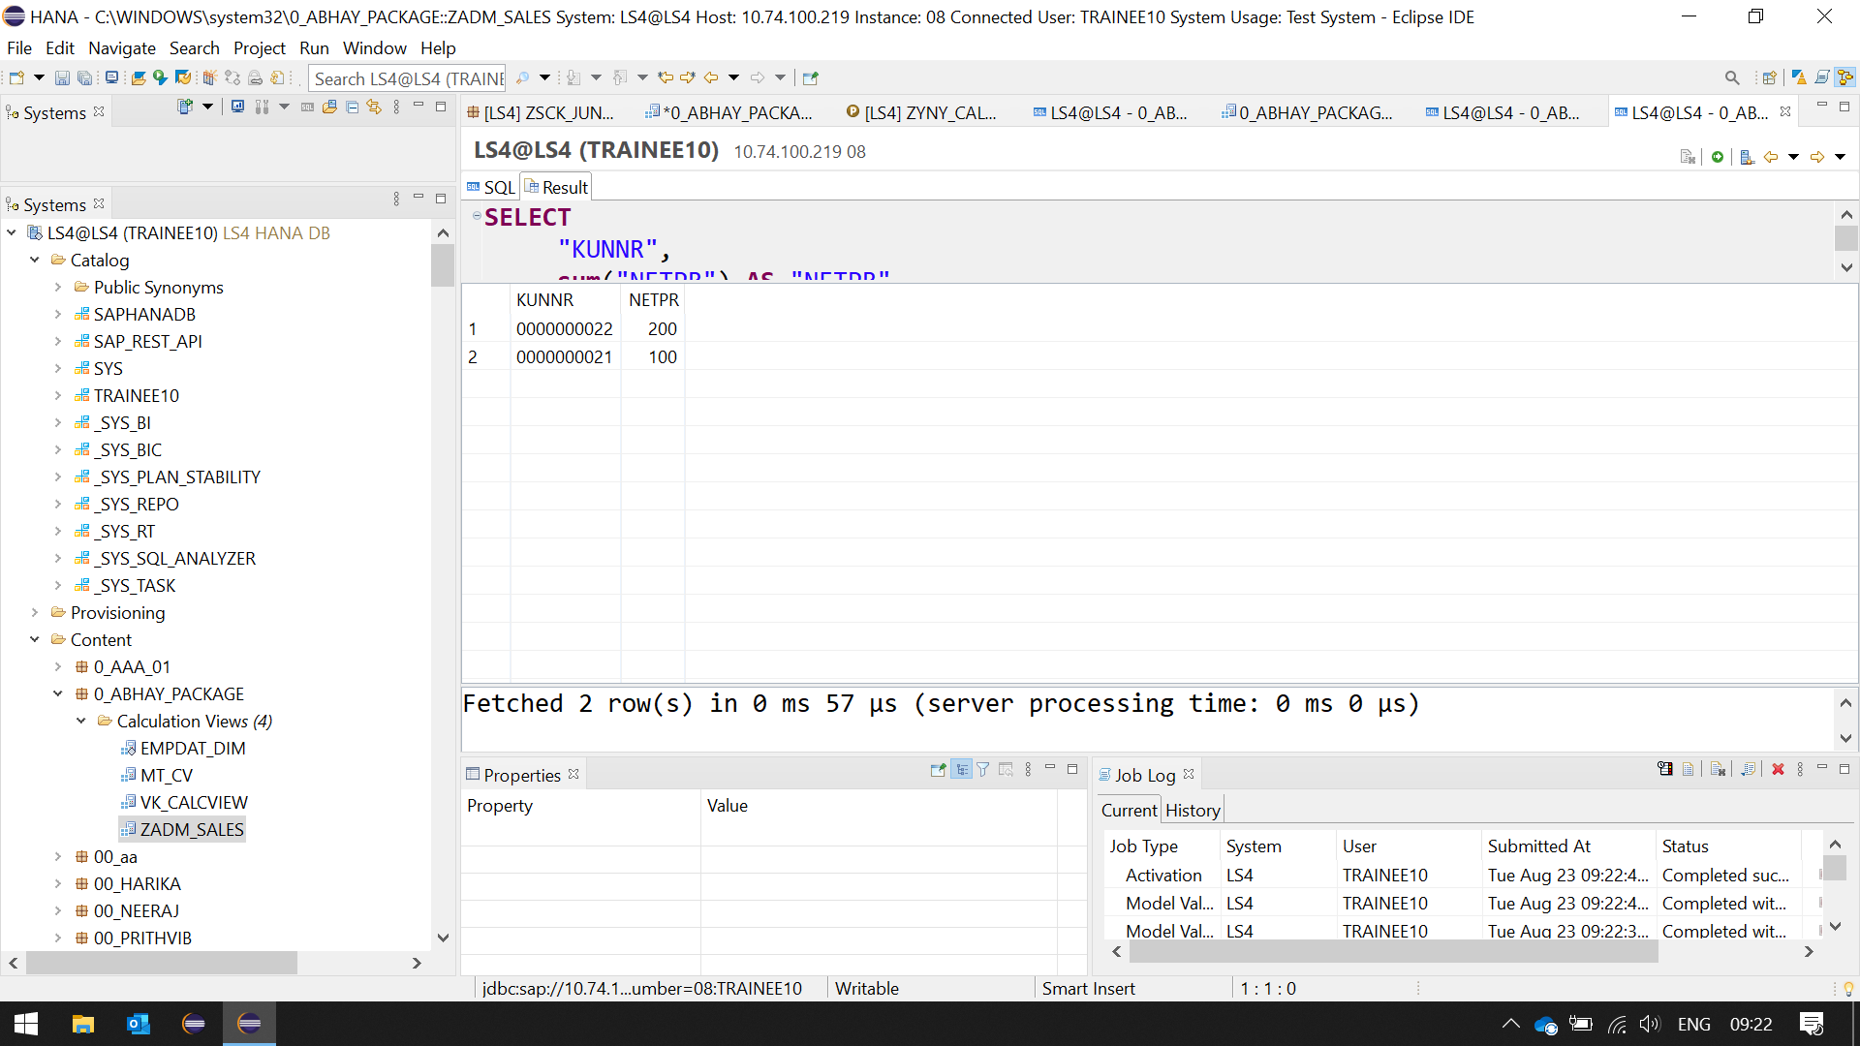

______________________________________________________________

Change Above to

2. SELECT * FROM "_SYS_BIC"."pkg-trainee01.Z104329/CALC_VIEW_SCRIPT3"

**SELECT** * **FROM** "_SYS_BIC"."0_ABHAY_PACKAGE/ZADM_SALES"

Execute this.

View the output.

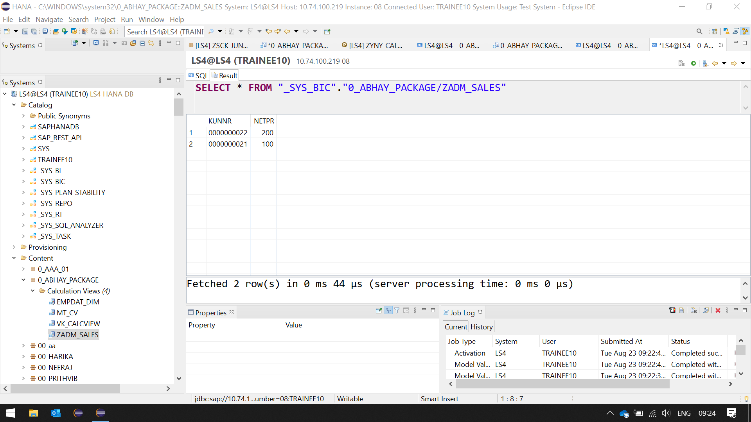

Observe difference in output in 1 and 2.

Use 1 and 2 in ADBC.

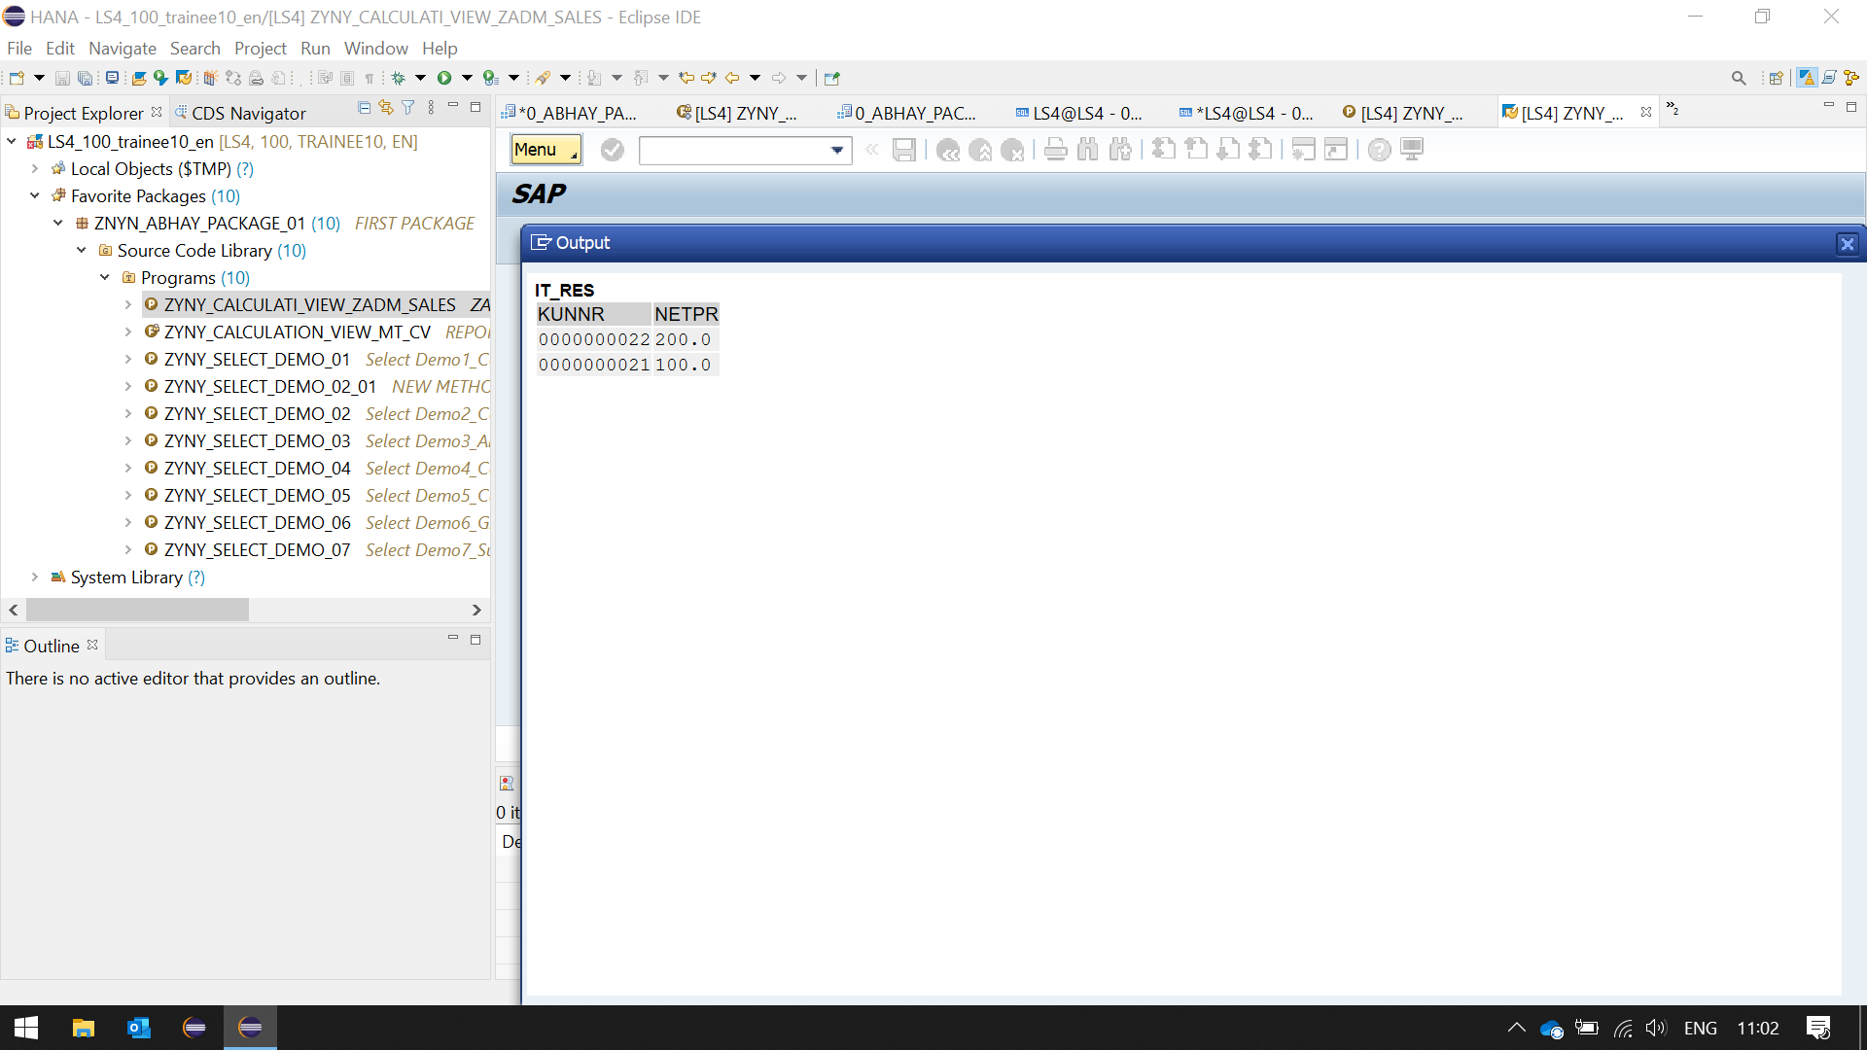

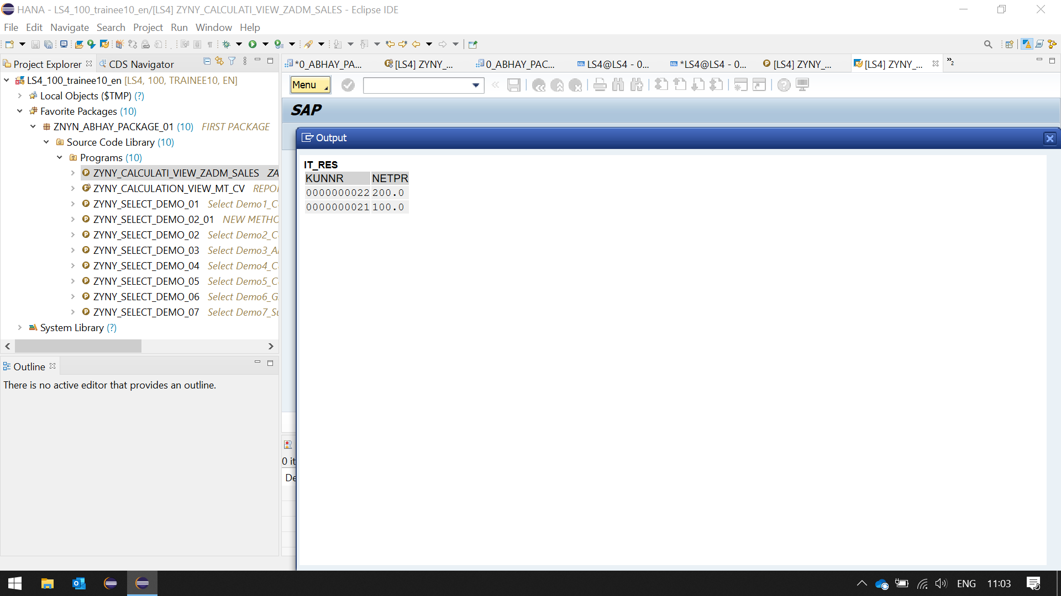

Observe difference in output in 1 and 2.

__________________________________________________________________________________

var_out = select kunnr , sum(netpr) as netpr

from SAPLS4.zadm_sales

group by kunnr;

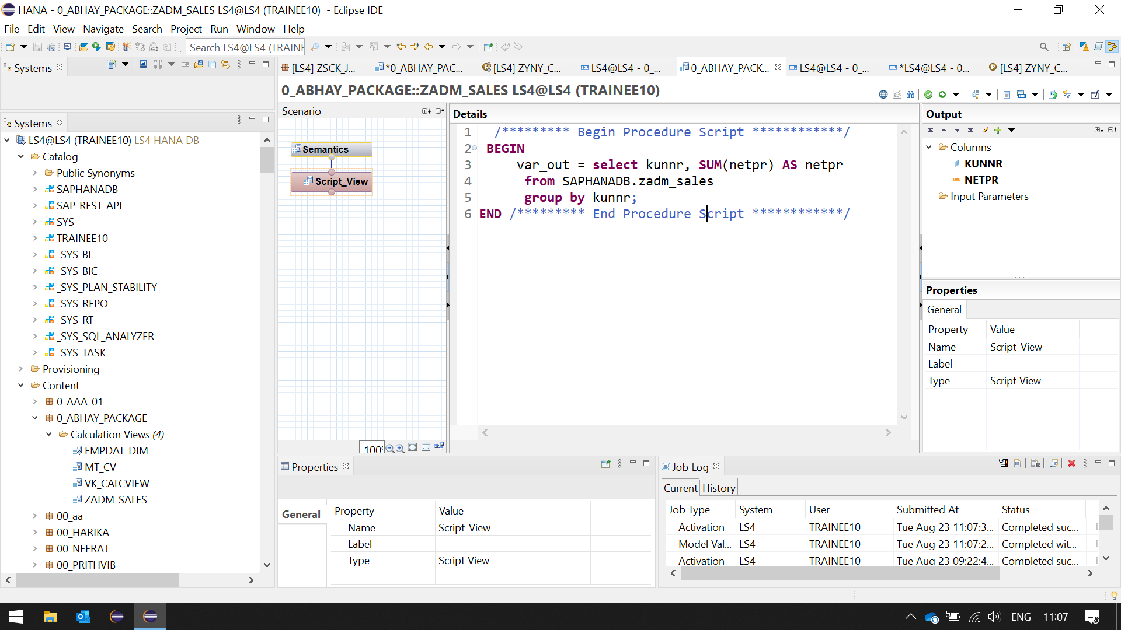

Generated SQL is

1. SELECT

"KUNNR",

sum("NETPR") AS "NETPR"

FROM "_SYS_BIC"."pkg-trainee01.Z104329/CALC_VIEW_SCRIPT3"

GROUP BY "KUNNR"

**SELECT**

"KUNNR",

**sum**("NETPR") **AS** "NETPR"

**FROM** "_SYS_BIC"."0_ABHAY_PACKAGE/ZADM_SALES"

**GROUP** **BY** "KUNNR"

Execute this.

View the output.

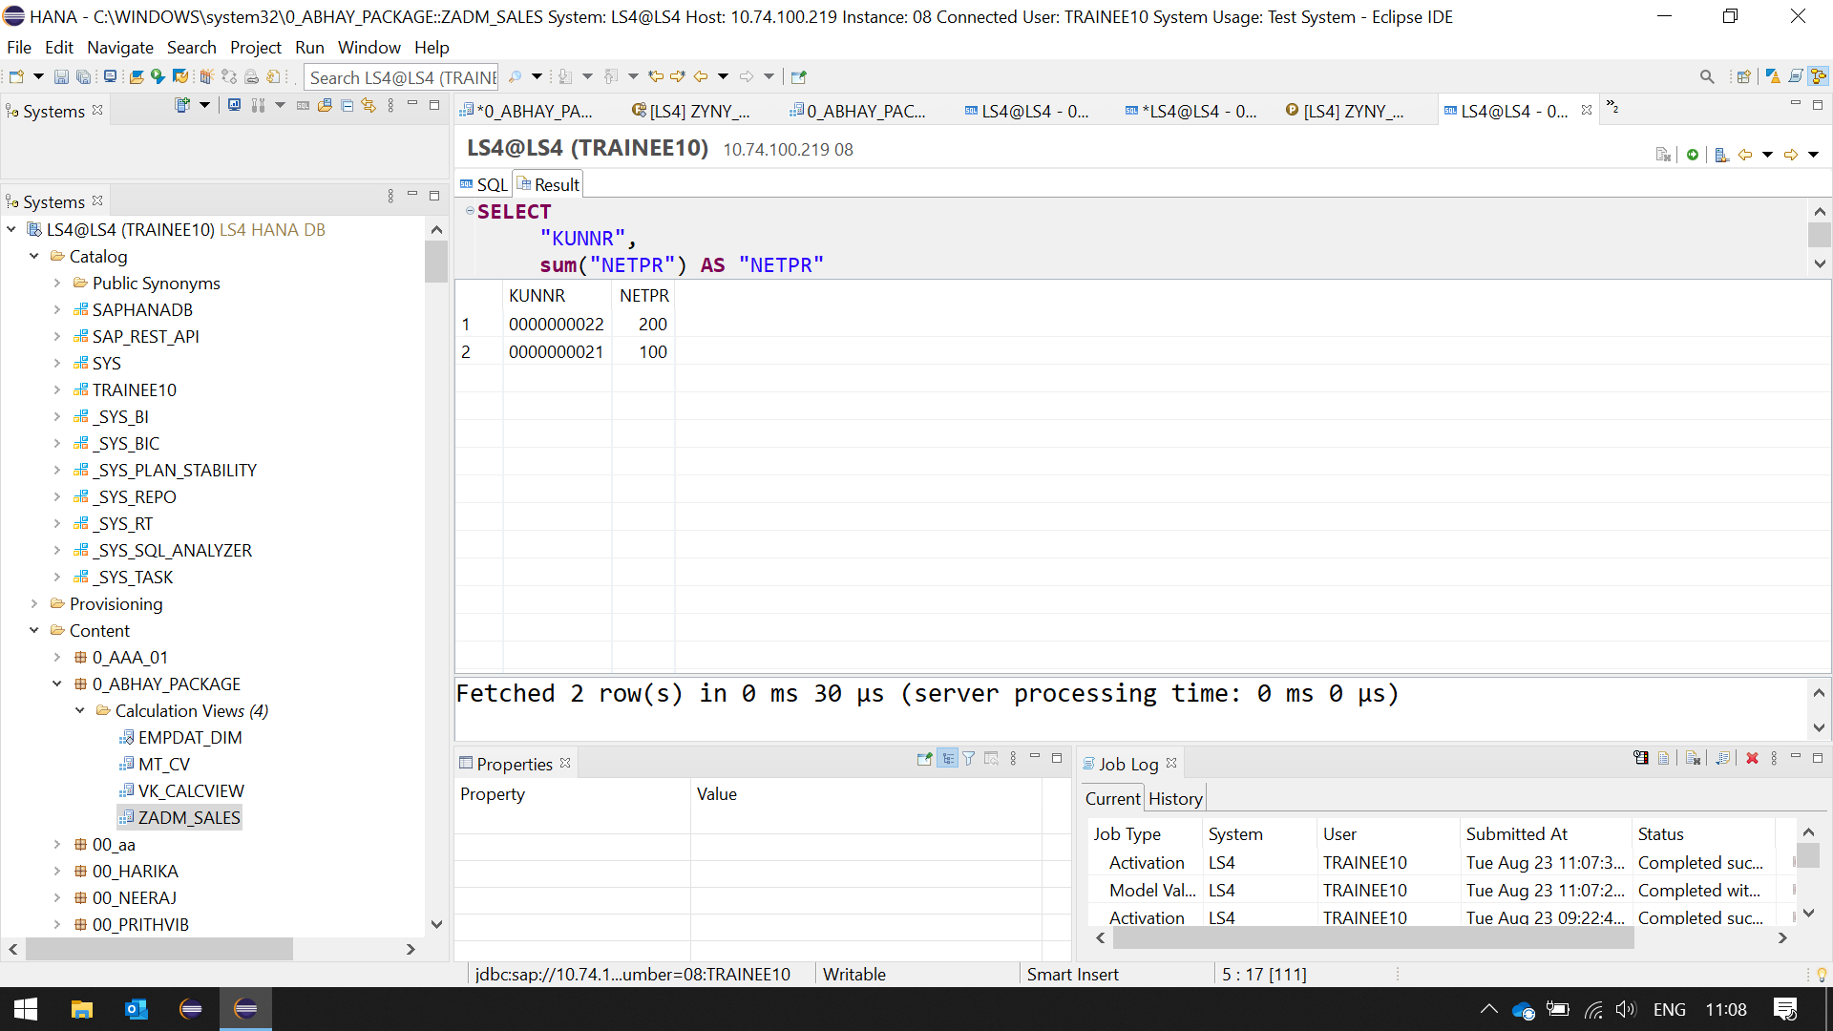

Change Above to

2. SELECT

*

FROM "_SYS_BIC"."pkg-trainee01.Z104329/CALC_VIEW_SCRIPT3"

**SELECT** * **FROM** "_SYS_BIC"."0_ABHAY_PACKAGE/ZADM_SALES"

Execute this.

View the output.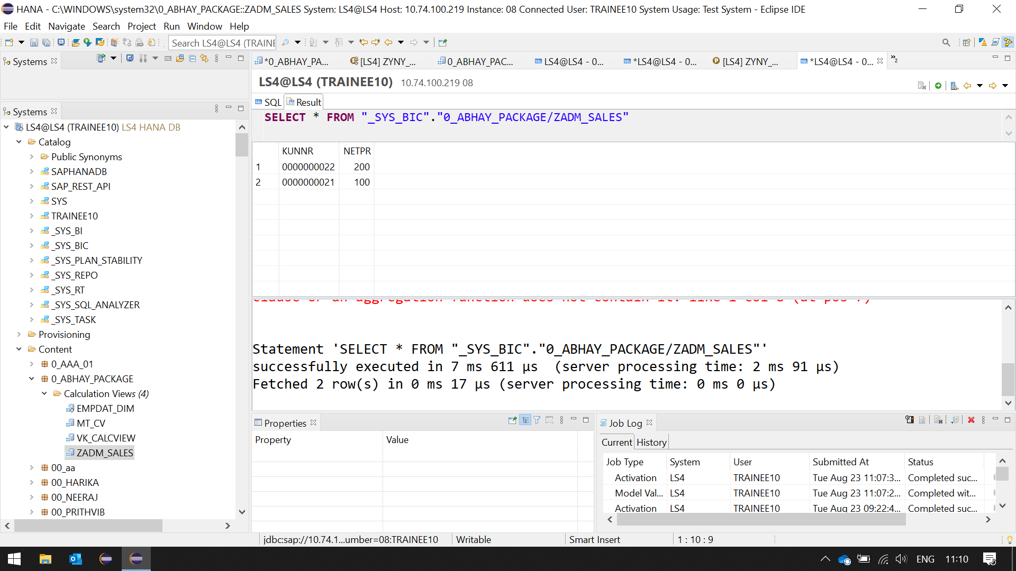

Observe difference in output in 1 and 2.

Use 1 and 2 in ADBC.

Observe difference in output in 1 and 2.